

CareMap Physician Dashboard
One screen. Every row opens a detail panel on the right.
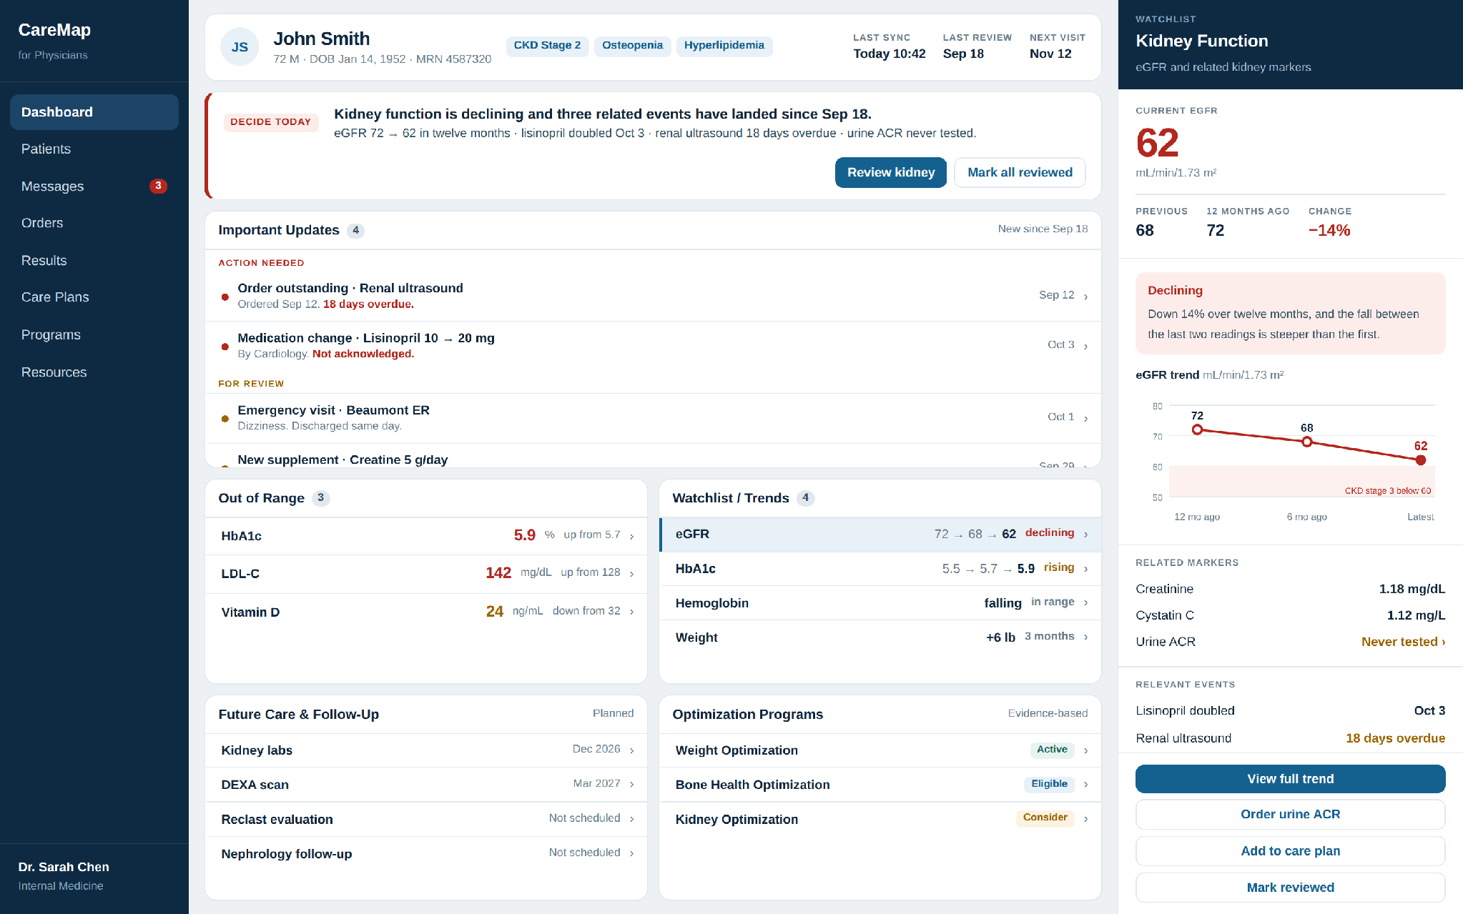
Default state, showing Kidney Function. Nothing on this screen requires scrolling.
What clicking gives you
Each row opens its own panel. These four come from Important Updates and Out of Range.
Renal ultrasound  Days overdue, who ordered it, and why it matters now  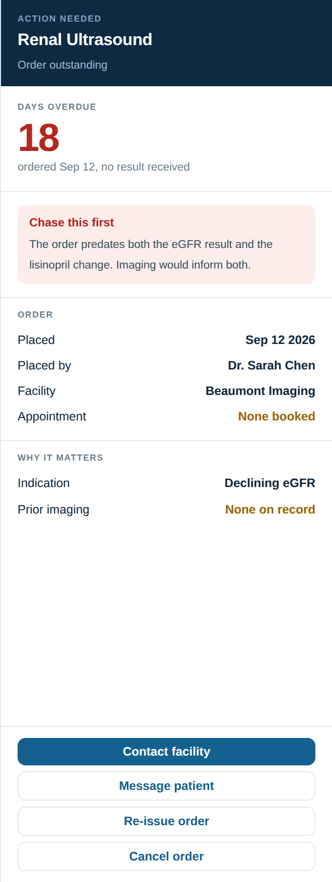 | Lisinopril  The dose change, and that eGFR has not been repeated since  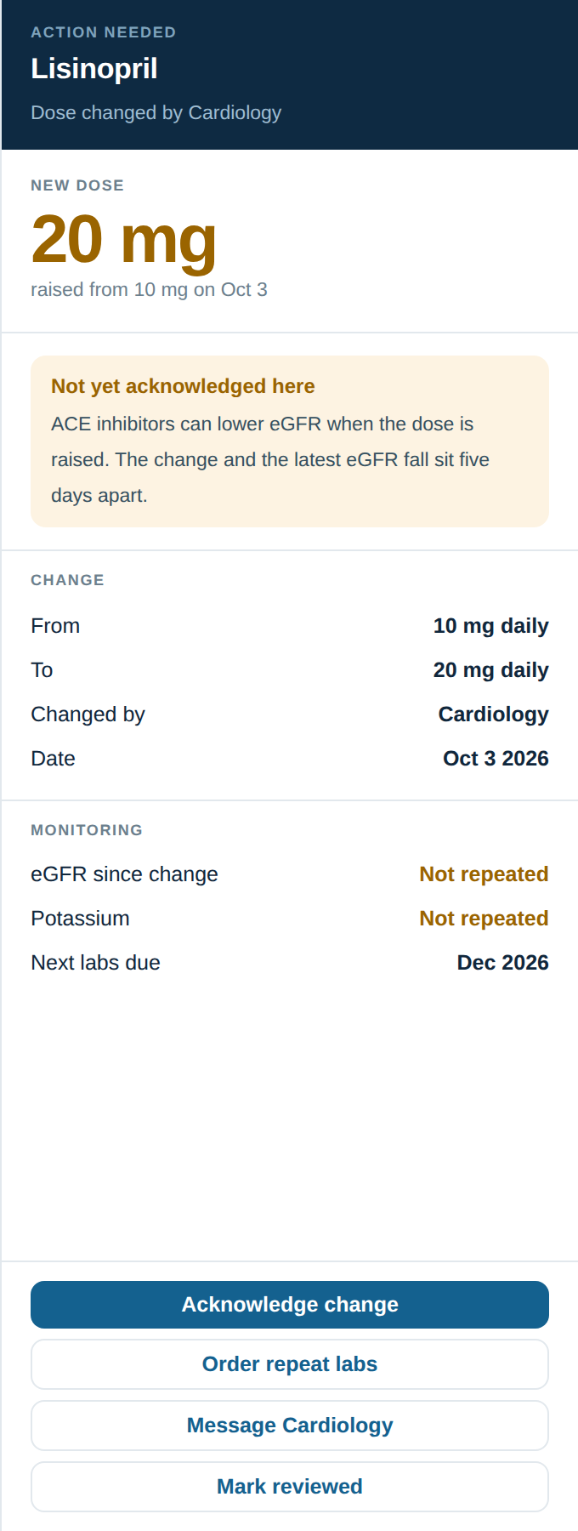 | Creatine supplement  Why this changes how the creatinine reads  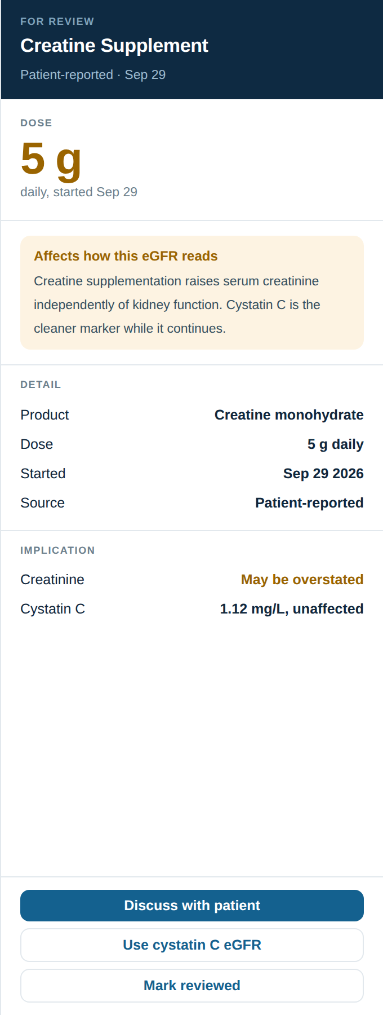 | HbA1c  Latest against range, with the twelve-month sequence  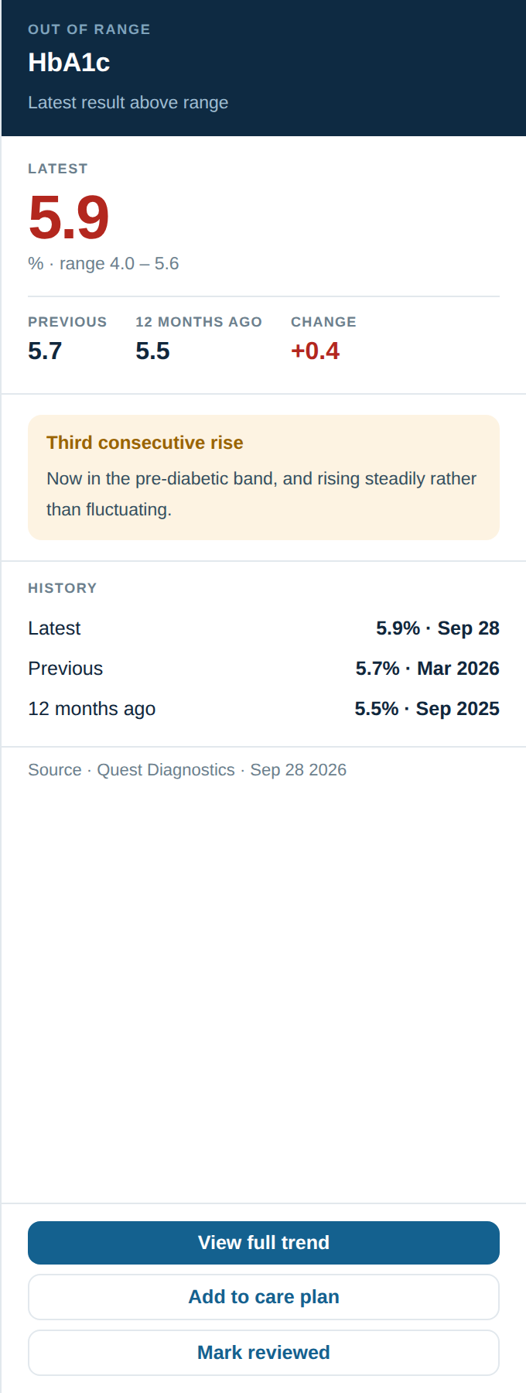
Eight of the seventeen subjects
These four come from Watchlist, Future Care and Optimization Programs.
Kidney function  The full trend with the CKD stage 3 threshold marked  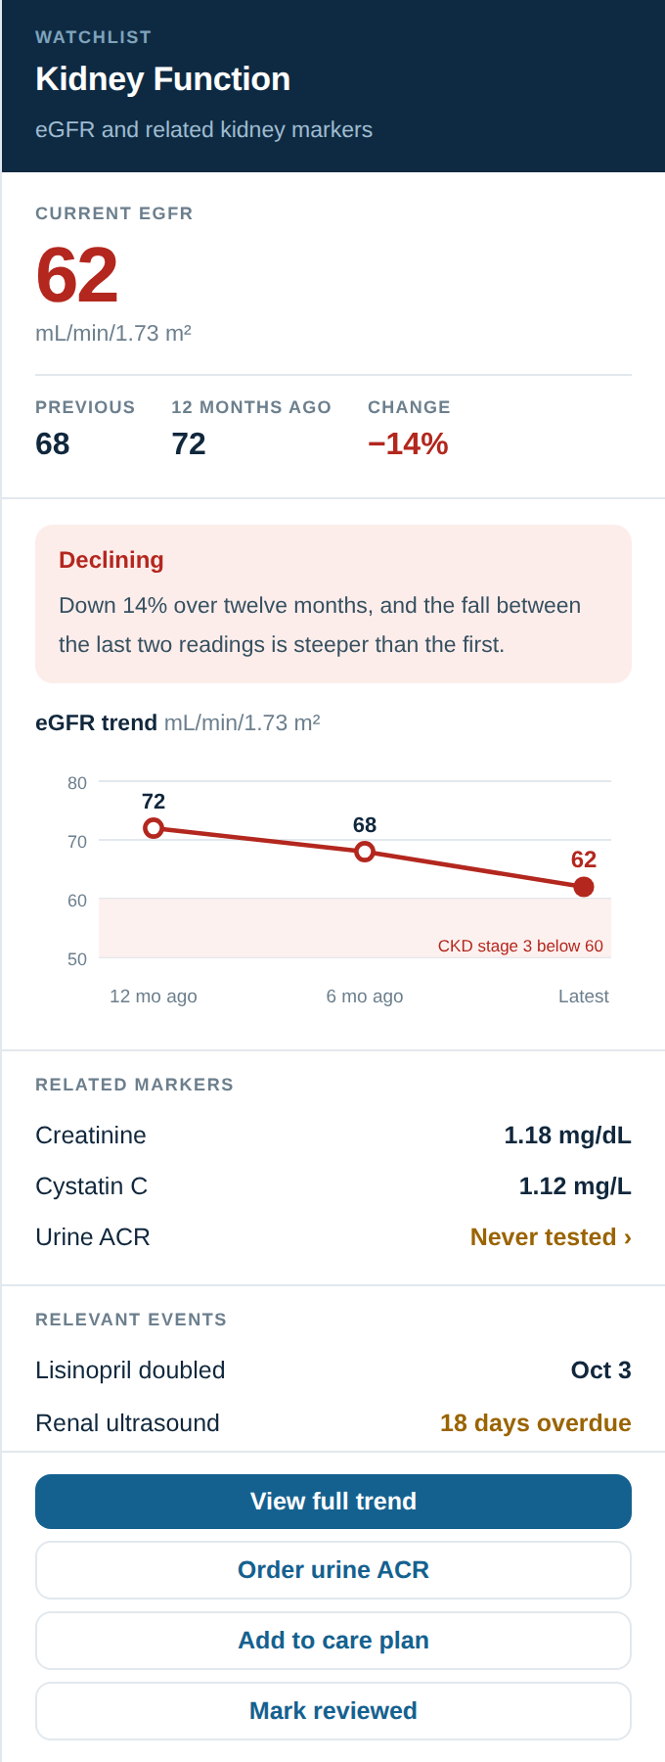 | Reclast evaluation  The contraindication, checked against this patient  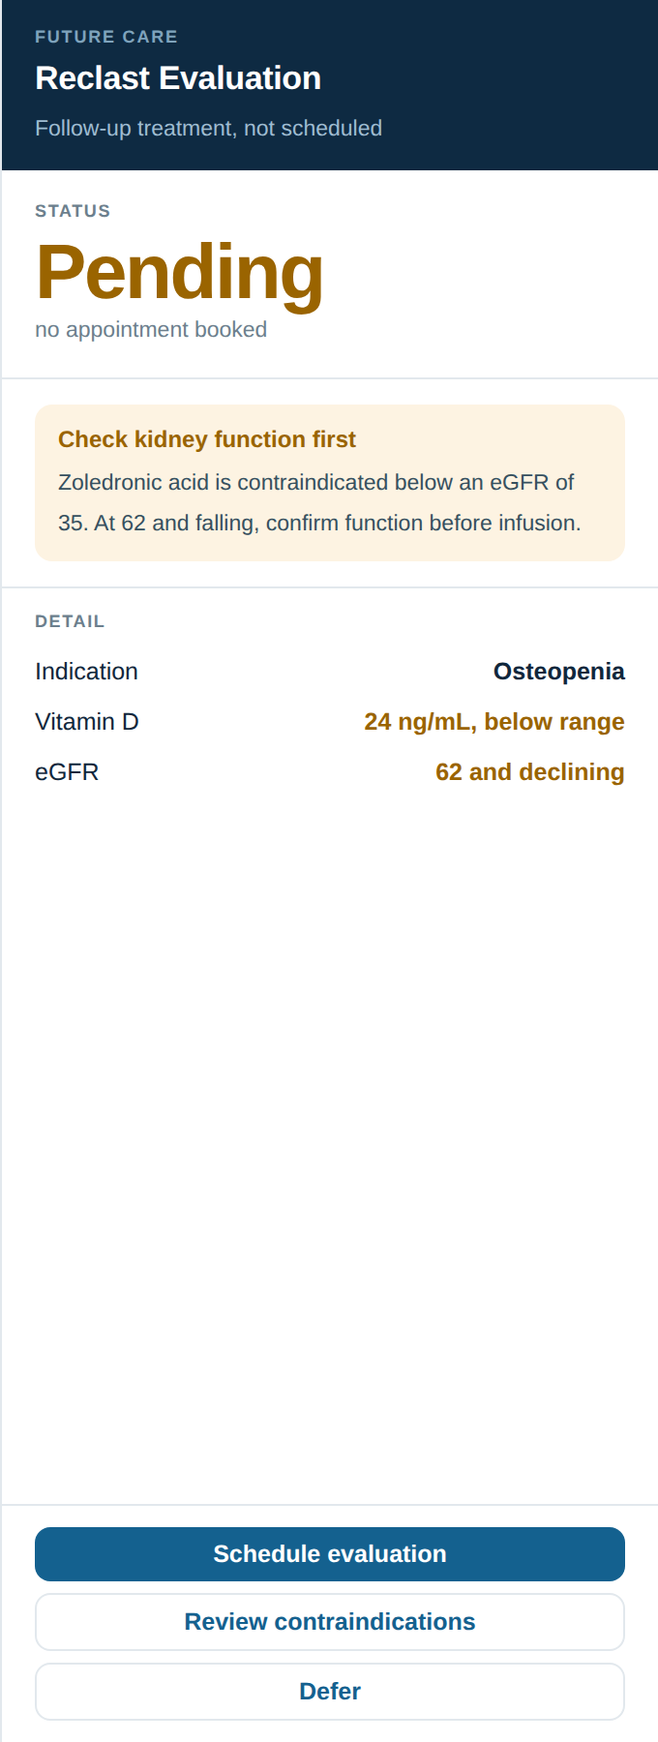 | Nephrology referral  Placed, never booked, and the case for expediting  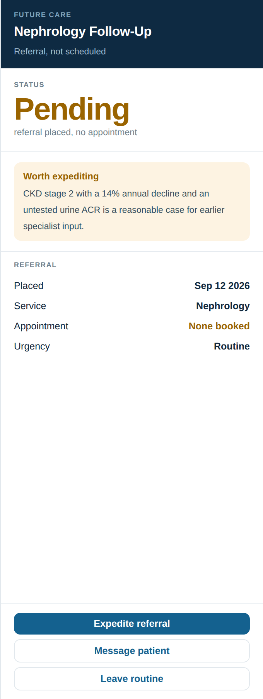 | Kidney Optimization  Why to hold enrolment until the imaging returns  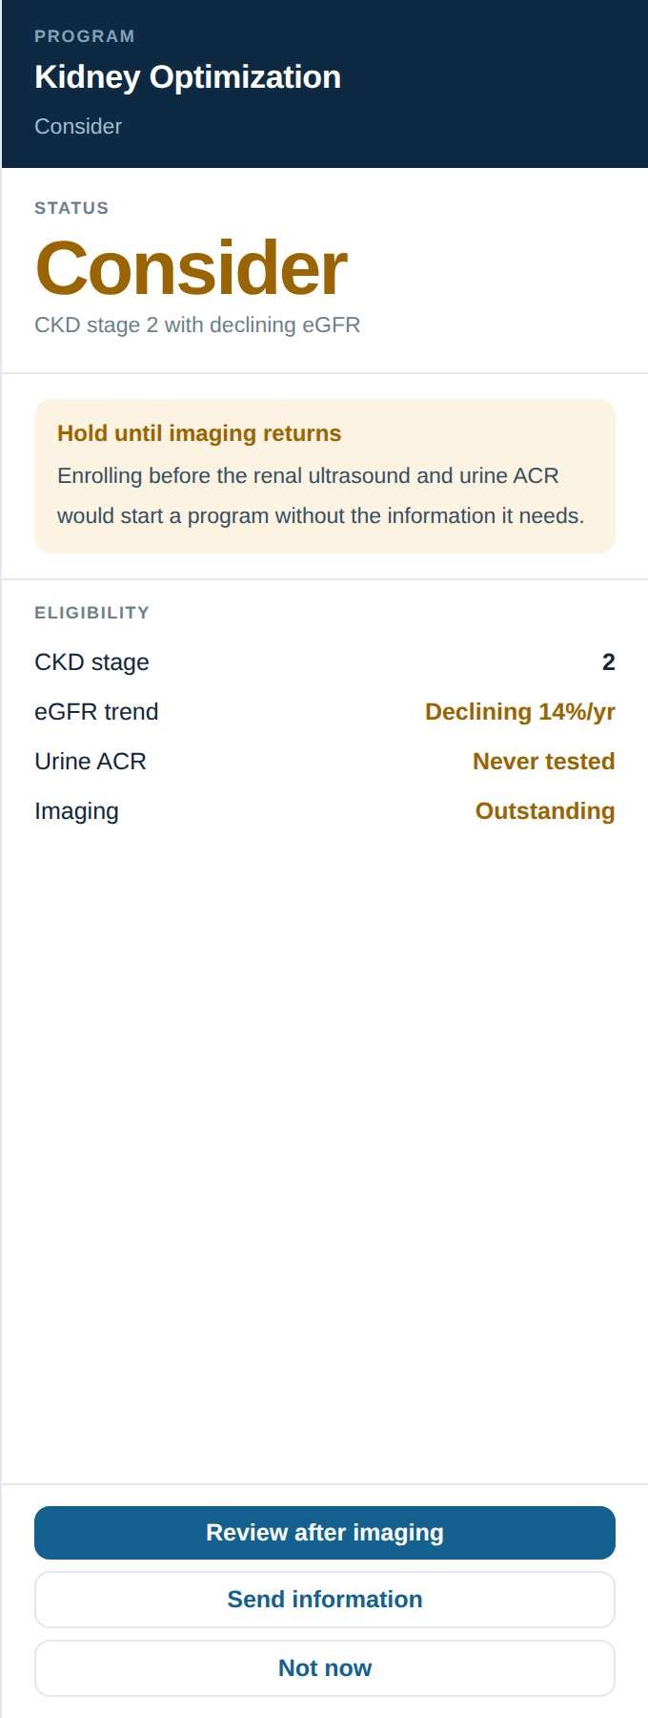
What changed from the first version
Every heading and every data point was kept. The hierarchy and the interaction changed.
Was | Now | Why
Six cards of equal weight | One decision band at the top | eGFR declining, lisinopril doubled, ultrasound overdue and urine ACR untested are the same clinical story. They were filed in four different cards. They are now stated together, with the actions attached.
Badges that inverted severity | Triage by what is required | “Action Needed” was amber and “Urgent” was pink, so the 18-day overdue order did not read as the most pressing item. Updates are now grouped under Action needed and For review, red before amber.
A fixed right panel | A panel that follows the click | The kidney detail was permanently docked. Any of the seventeen subjects now opens there, with its own figures, clinical note and actions.
A green tick on a 14% decline | An amber warning | A fall of that size is not a success state. The note now also observes that the recent rate is steeper than the earlier one.
“Not Tested” in neutral grey | A flagged gap | An untested urine ACR is a missing piece of CKD staging, not a neutral value. Absences are now amber and clickable throughout.
A trend line without context | A threshold on the chart | The eGFR line now shows the CKD stage 3 boundary at 60. The patient sits two points above it, which is the reason the trend matters.
Two decisions remain open: whether this is branded CareMap or Inlay Health, and whether the action buttons drive the nine-state order lifecycle or stay presentational.

